Project Development Phase
Model Performance Test

Date | 08 October 2026
Team ID | 9100RootAccess
Project Name | Auto Ticket Classification using ServiceNow Flow Designer
Maximum Marks

Model Performance Testing:
Project team shall fill the following information in model performance testing template.
S.No. | Parameter | Values | Screenshot
 | Model Summary | ServiceNow Flow Designer automation for auto ticket classification of school IT helpdesk tickets, using a custom table (Incident WorkFlow – u_incident_workflow), dependent Category/Subcategory choice fields and the flow “Auto Classify School IT Tickets” (Trigger: Record Created, Category is empty).  Note : If the Short description matches a keyword rule (Wi-Fi/Network, Projector, Forgot password, Slow computer), Category and Subcategory are filled automatically and an email is sent to the caller. If nothing matches, the ticket stays unclassified for manual handling. | 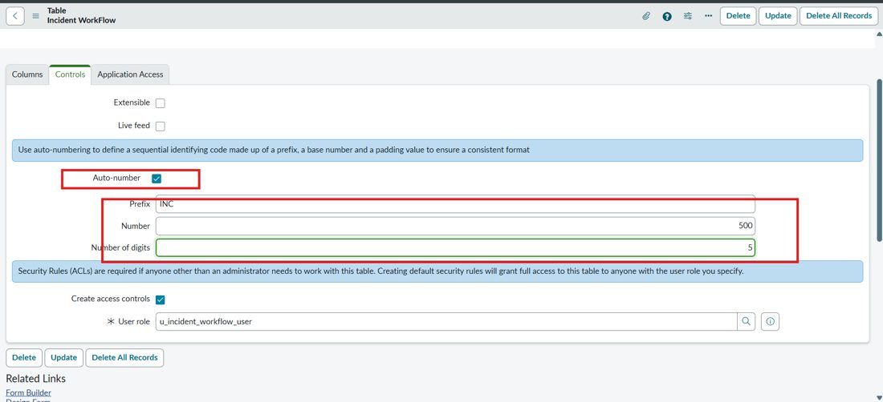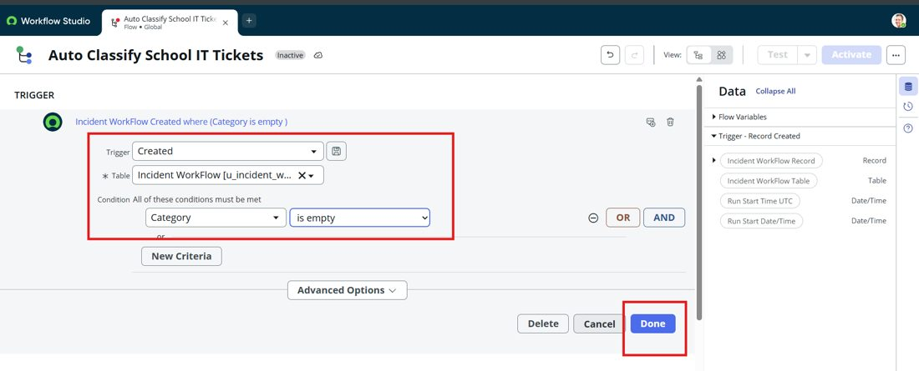
 | Accuracy | Training Accuracy – Not applicable (rule-based flow, no ML model is trained)  Validation Accuracy – 100% on the executed test scenarios (2 of 2 tickets classified correctly: INC00511 → Network / Wi-Fi, INC00512 → Hardware / Projector) | - 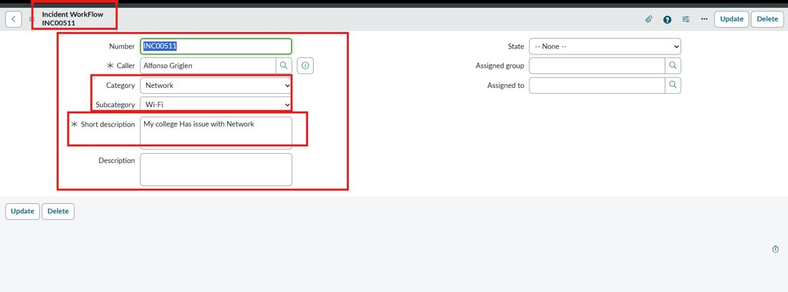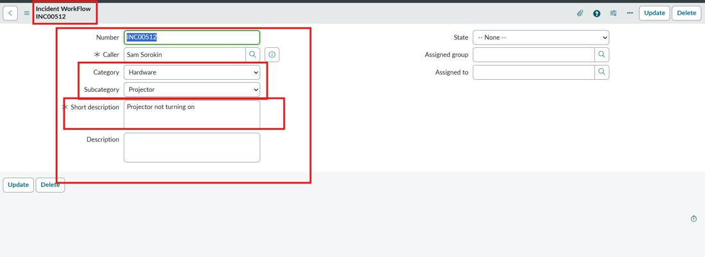
3. | Confidence Score (Only Yolo Projects) | Class Detected – Not applicable (no YOLO / ML model used). Equivalent check: keyword condition matched in the flow and Category + Subcategory updated on the ticket.  Confidence Score – Not applicable. Flow execution confirmed by the automatic email “Your Request for the issue has been submitted.” sent to the caller. | 